Synamedia MEG – Upgrade SOP

Task – Upgrading Synamedia MEG to Version 24.02.03-79

- Log in to Synamedia MEG IRD (Default ip – 192.168.2.20/24, port 3)
  - Admin
  - Password
- Navigate to Advanced View in upper left corner (3 lines)
- Navigate to the Configuration tab on left side
  - Click on the Version Info section (see Figure-1)
  - Click on Choose File
    - Navigate to upgrade file location (file name - meg-installer-24.02.03-79.rocky9.zip)
      - Before clicking Add Installer, Tick the box After Upload - Install when upload is done (Figure-2 is how it should look)
    - Click Add Installer
      - It will now begin the upgrade process
  - After the file is finished uploading, it will automatically begin installing the new update
  - Note: Depending on the browser used for the upgrade, it’s possible to receive some error messages indicating the final verification failed as follows:
“Installation of MEG version 24.2.3-79 completed.”
“Final verification of the system has failed.”
    - This error shows up when there is about 1:12 left and is a known issue with the installer. The upgrade is complete.
        - Once the installer is finished and the unit has rebooted, refresh the log in page and it should now show V24.02.03 on the Log in Page (Figure-3)
- Upgrade complete.

Figure-1
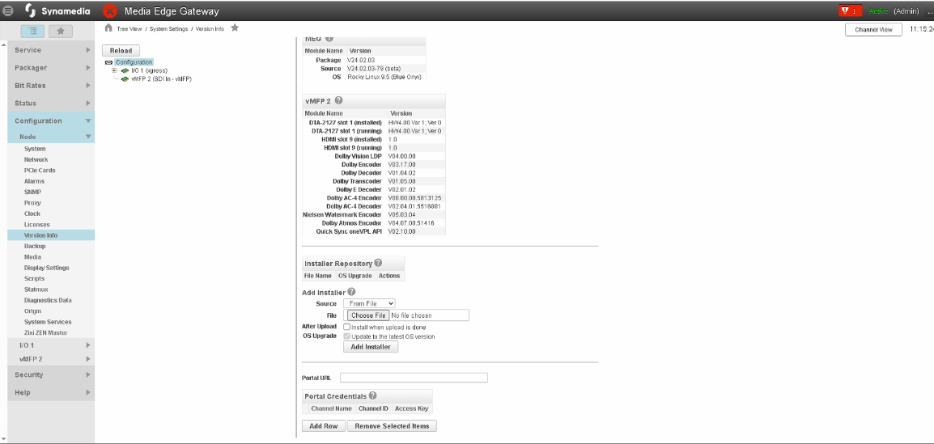
Figure-2
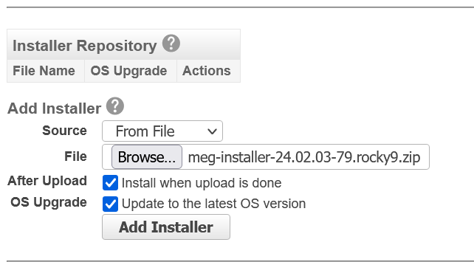
Figure-3
